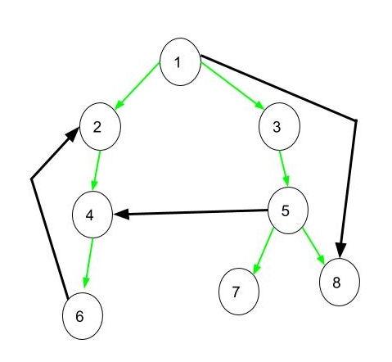

**All applicable after applying DFS on the GRAPH.**

**Tree Edge**: It is an edge which is present in the tree obtained after applying DFS on the graph. All the Green edges are tree edges.

**Forward Edge**: It is an edge (u, v) such that v is descendant but not part of the DFS tree. Edge from **1 to 8** is a forward edge.

**Back edge**: It is an edge (u, v) such that v is ancestor of edge u but not part of DFS tree. Edge from **6 to 2** is a back edge. [Presence of back edge indicates a cycle in directed graph](https://www.geeksforgeeks.org/detect-cycle-in-a-graph/).

BOTH FORWARD EDGE AND BACK EDGE ARE NOT PART OF THE DFS TREE.

**Cross Edge**: It is a edge which connects two node such that they do not have any ancestor and a descendant relationship between them. Edge from node **5 to 4** is cross edge.